TimeSprite

Status Reports and Project Submissions

Date: 24/10/2016 to 16/11/2016

University of the Pacific

COMP 191, Senior Project, 2016 Fall ---Yunpeng Zhang

Contents

2 Project Schedule 2

3 Currents Status 3

3.1 Finished Tasks 3

3.2 Falling being schedule 3

4 Plan for next work period 4

4.1 Task for next work period 4

5 Challenges and concerns 5

6 updated artifacts 6

# Project Schedule

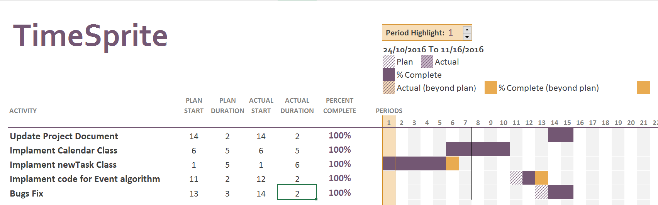

# Currents Status

## Finished Tasks

1. Update Project Document
   1. Fixed some spell and grammar problems
   2. Update new interface and interface interaction diagram
2. Implement newTask class
3. Implement generateCalendar Class
4. Implement Calendar Calss
5. Bugs Fix

## Falling being schedule

All Tasks finished, but overdue few days. Because implement code spent a lot of time.

# Plan for next work period

## Task for next work period

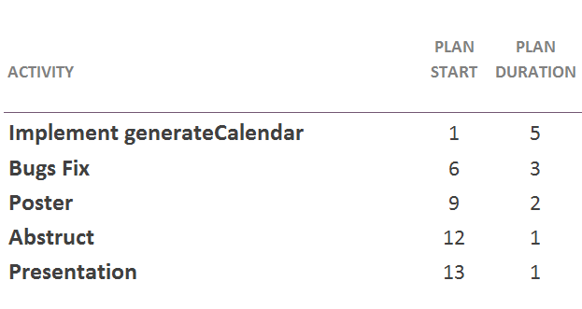

# Challenges and concerns

This project almost done. But need I may need more time to polish code and fix some bugs. Everything looks good, and it met requirements.

# updated artifacts

1. Requirements Analysis Document
2. Application Source Code
3. Gantt Chart
4. New interface screen shot
5. Next sprint plan